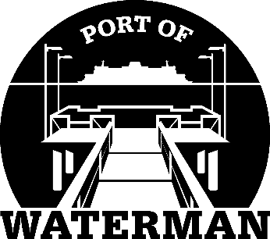

**Port of Waterman Meeting Agenda**

**August 20, 2024**

* Review/Approve Agenda
* Review/Approve Prior Meeting Minutes
* Review/Approve Auditor’s Report
* Review Financial Statement

**Old Business:**

* Maintenance Update
* Tycor Replacement
* IT Support/Cameras

**New Business:**

* **Small Ports Conference (October 23-25)**
* **Fishing Season Updates?**
* Commissioner District Reports