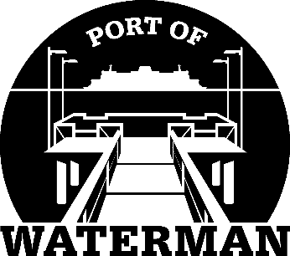

**Port of Waterman Meeting Agenda**

**February 18, 2025**

* Review/Approve Agenda
* Review/Approve Prior Meeting Minutes
* Review/Approve Auditor’s Report
* Review Financial Statement

**Old Business:**

* Maintenance Update
* Tycor Replacement
* Comprehensive Plan

**New Business:**

* Commissioner District Reports