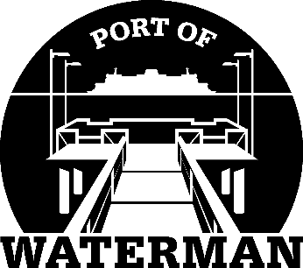

**Port of Waterman Meeting Agenda**

**April 15, 2025**

* Review/Approve Agenda
* Review/Approve Prior Meeting Minutes
* Review/Approve Auditor’s Report
* Review Financial Statement

**Old Business:**

* Establish Maintenance Schedule

**New Business:**

* Commissioner District Reports